API Testing – Backend Testing

Manual Testing Tool – Postman

Automation Testing Tool – Rest Assured

Client & Server

Server: A Computer that serves the services/application(webpage/information/data)

Client: A computer that makes the request for application to the server

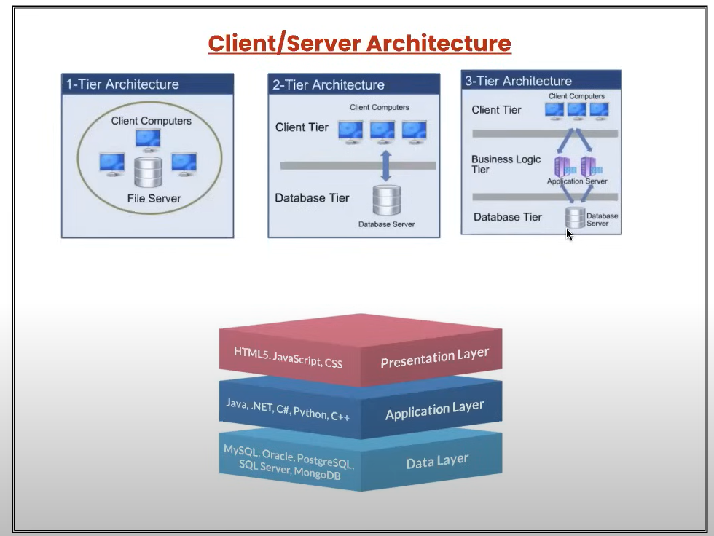

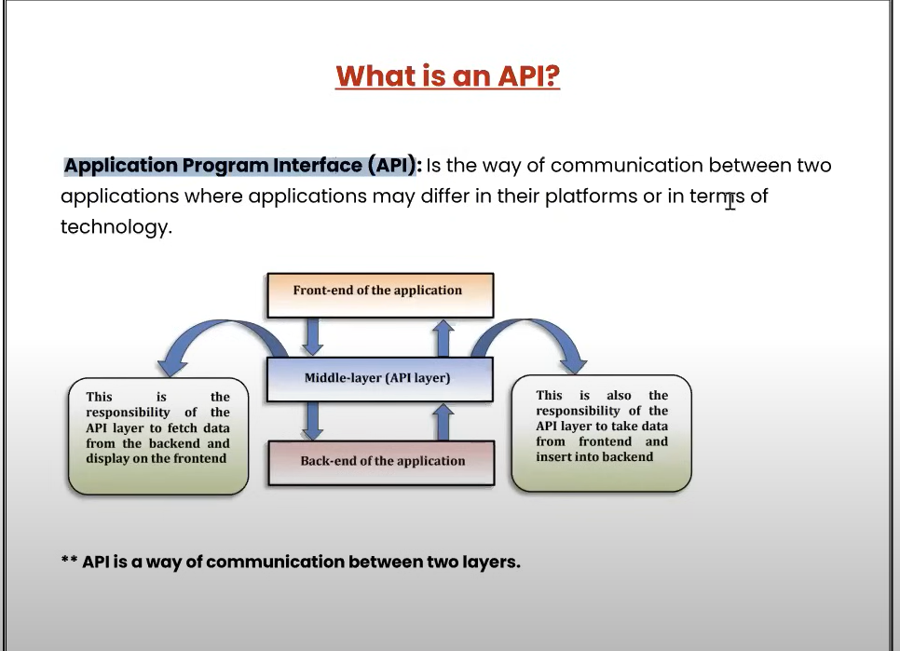

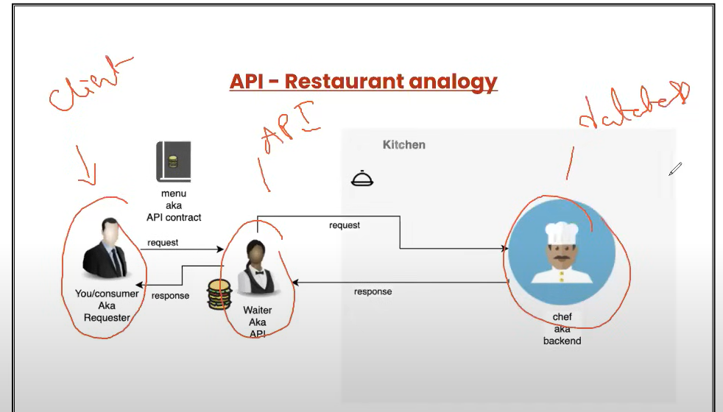

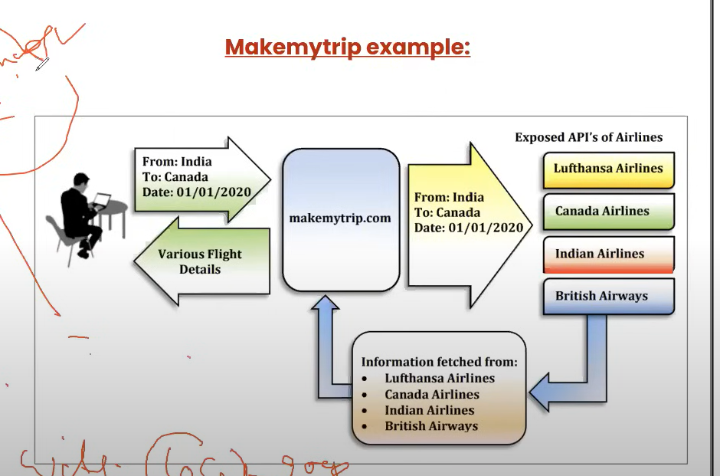

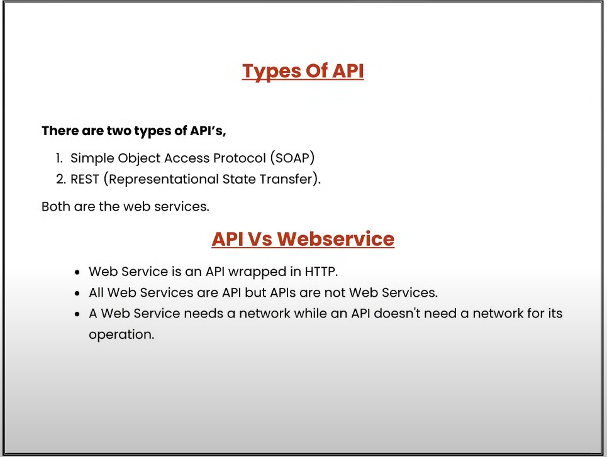

The main difference between an API and a Web Service is: API is used internally (not placed on the internet), once an api is placed on the internet, it’s called Web Service.

REST API Methods / HTTP Request

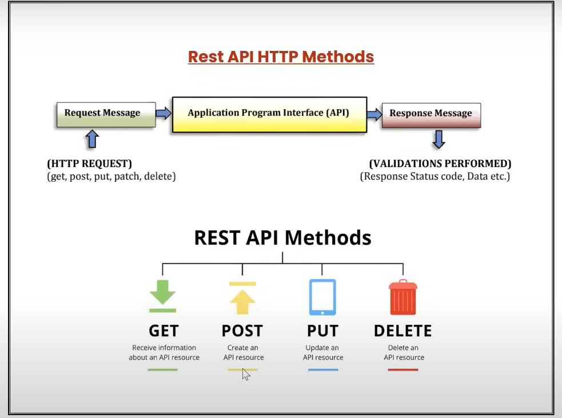

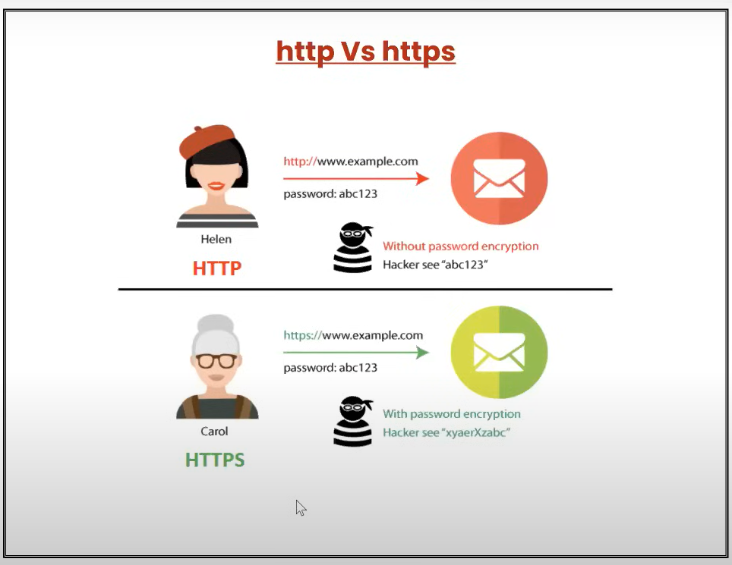

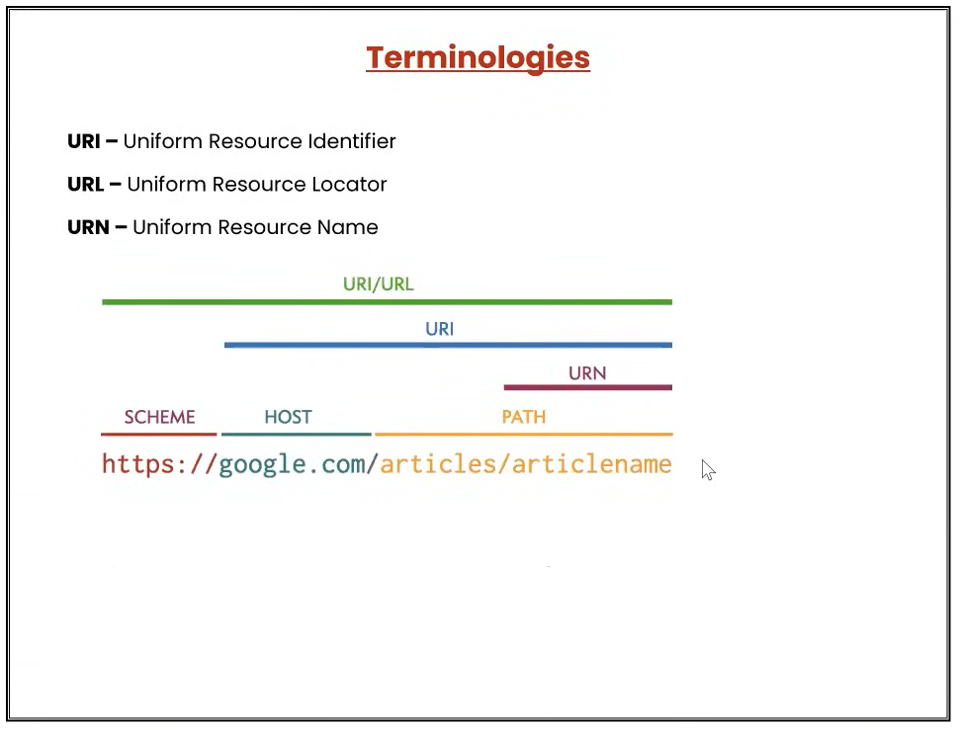

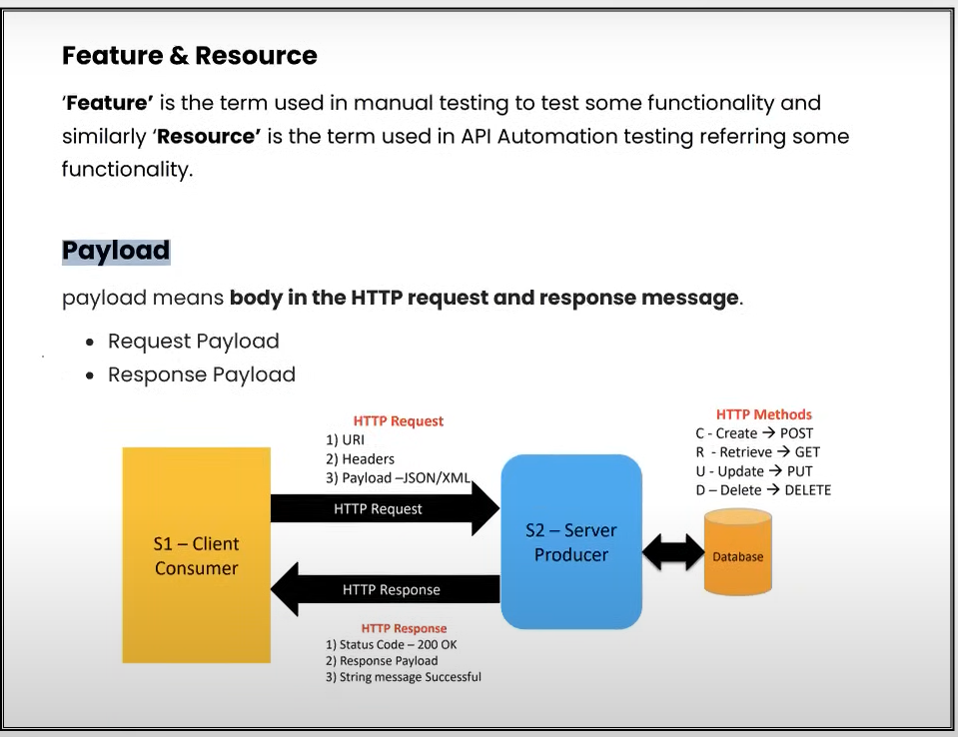

Request Payload & Response Payload: The data which we send with the request is called Request Payload and the data we receive with the Response is called as Response Payload.



